Custom Business Rules Implementation Procedure

Procedure:

Develop the logic and update messages in resource java file.

- Pls refer the below screenshots and the sample java files which will show the logic for Custom Business Rule formats.
- Below are the screenshots of Sample Custom Business Rules format.
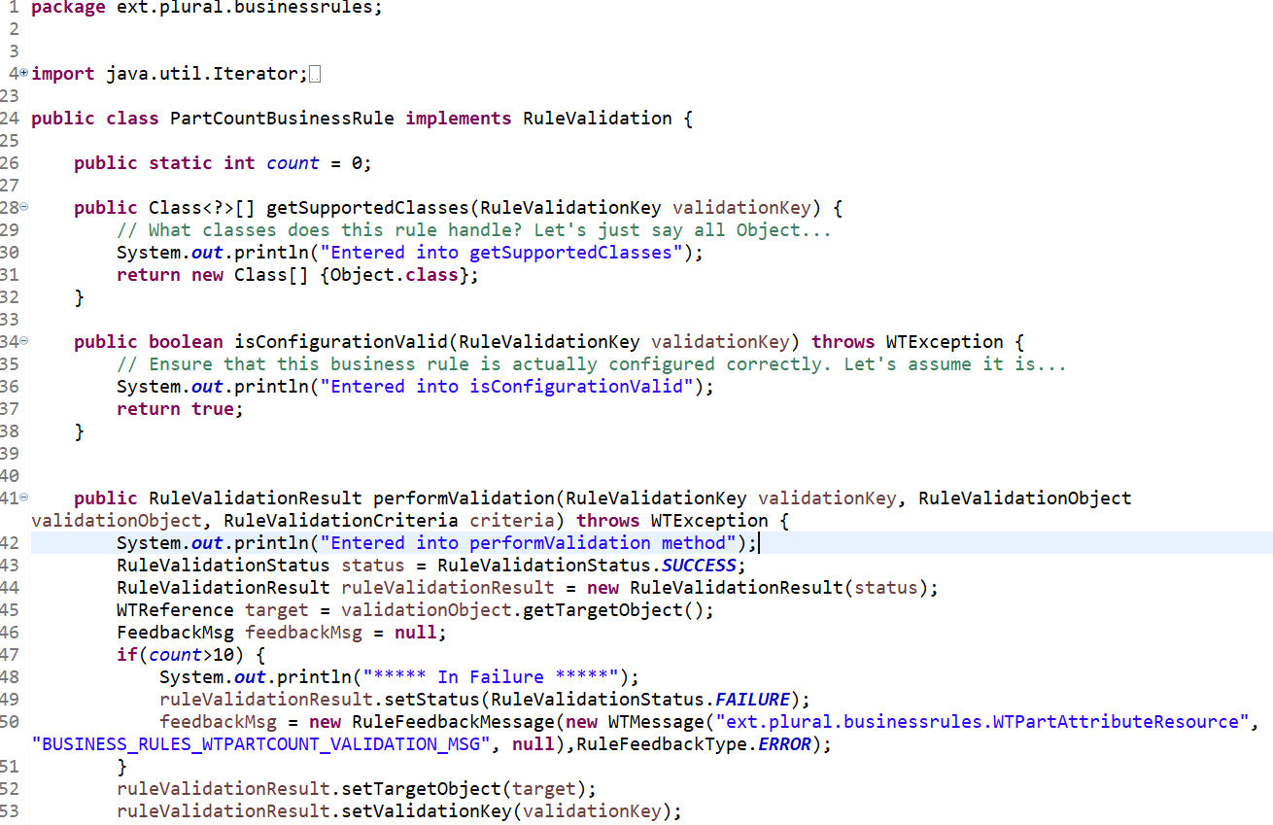
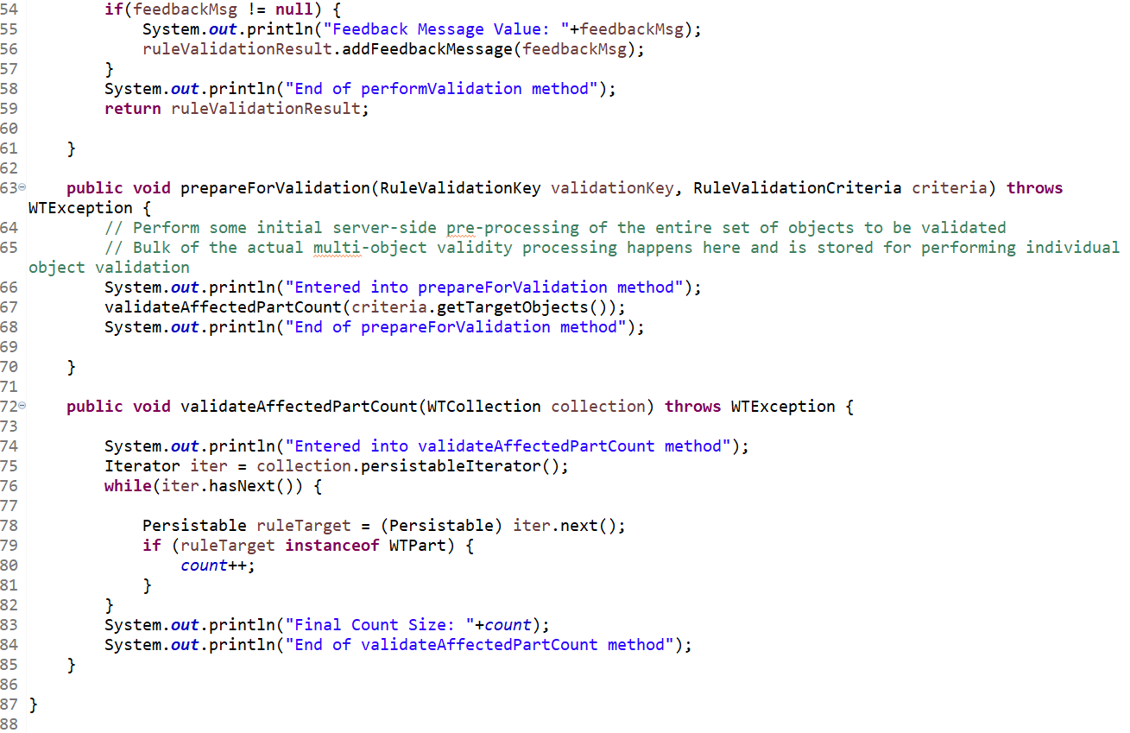

- Below is the screenshot of message resource java file used in the Custom Business Rule.
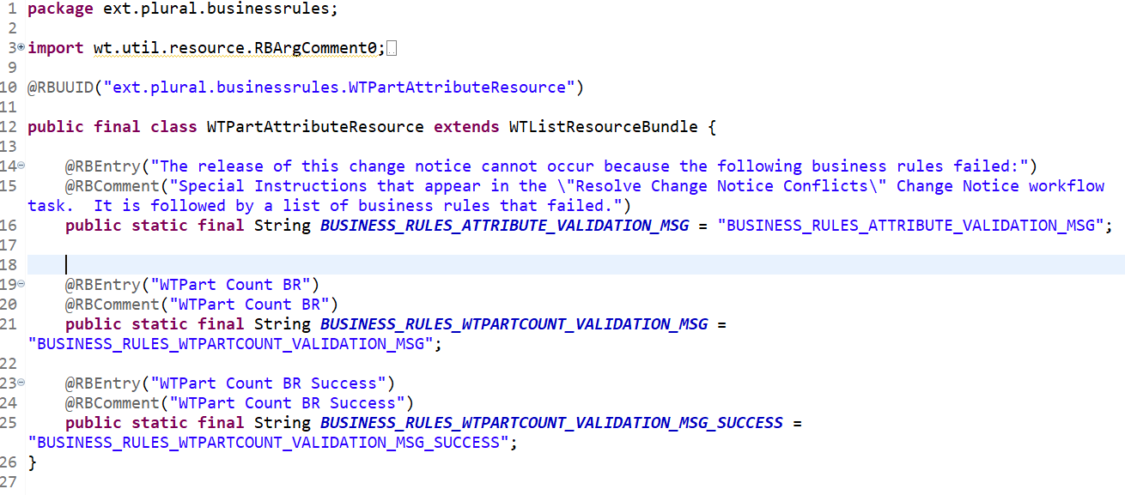

- Compile both the java files and restart Windchill with clean cache.

Define New Business Rules.

- Define Business Rule
- Define Business Rule Set
- Define Business Rule Link

- We can define our own business rules by creating and loading XML files.
- Below is the xml file in which the Business Rule was defined.
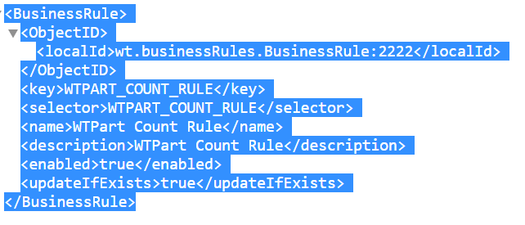
- Below is the xml file in which the Business Rule Set was defined.
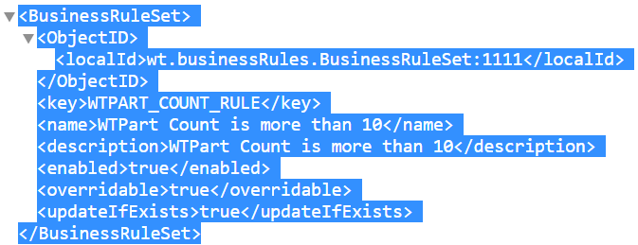

- Below is the xml file in which the Business Rule Link was defined.
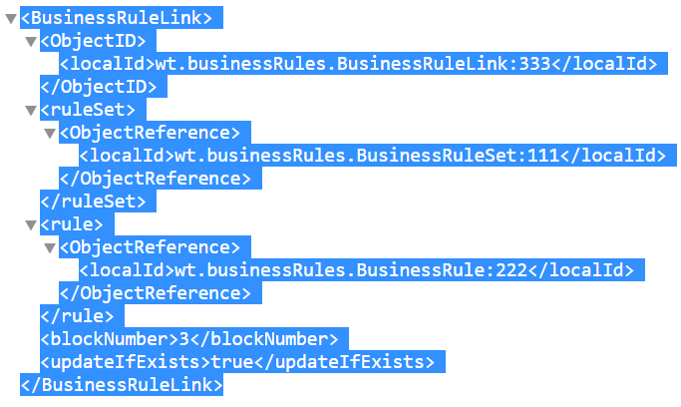

Register the Custom Business Rule

Note: This property should be registered before loading or else loading will fail

- Add the property in the below file and execute xconfmanager.
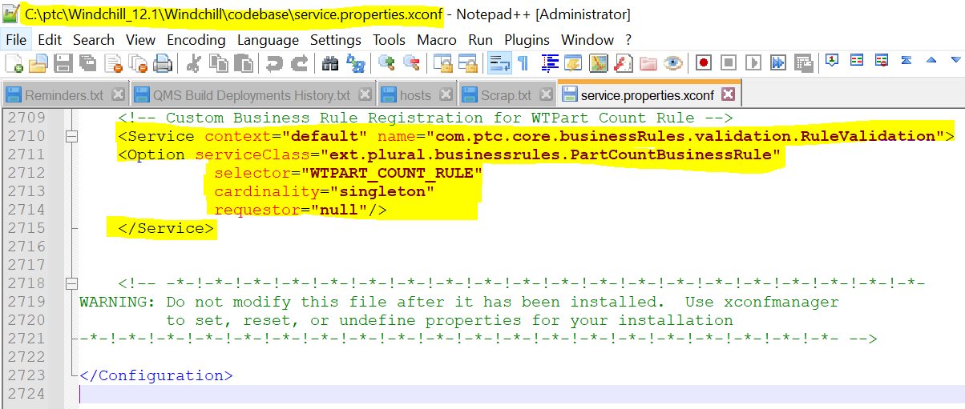

- Restart Windchill with clean cache.

Loading Business Rules Objects

- Add the load xml files to a zip file. For example, add the CustomeBusinessRule.zip file such as:

<windchill>/loadFiles/ixbImport/AttributeRule.zip

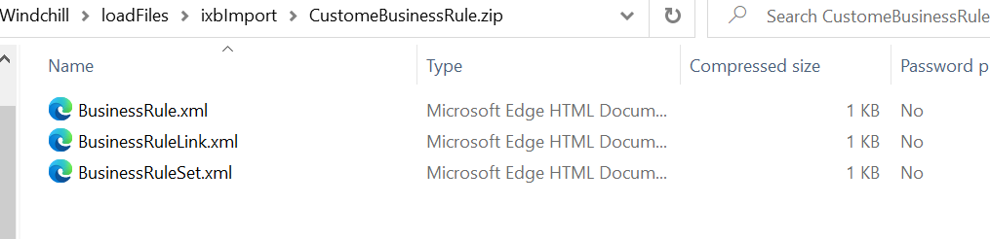

- Create the XML load file to load the generated zip file created in step 1.
Note: We shouldn’t to mention the entire Windchill just mention as shown in screenshot.
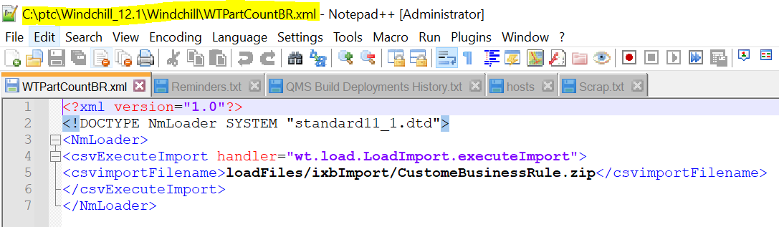

- Using a windchill shell, execute the following load command to load the business rules objects.

windchill wt.load.LoadFromFile -d <PATH>\loadFileName

- Once the objects were loaded into Windchill it should be visible under Site Utilities Business Rules.
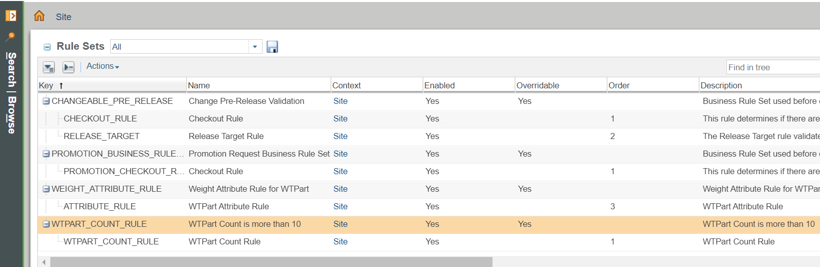

Calling the Business Rules Engine

- Update the workflow to call the Business Rule as shown below.
com.ptc.core.businessRules.engine.BusinessRuleSetBean defaultBean = com.ptc.core.businessRules.engine.BusinessRuleSetBean.newBusinessRuleSetBean("WTPART_COUNT_RULE", "wt.change2.AffectedActivityData");
com.ptc.core.businessRules.engine.BusinessRuleSetBean[] beans = new com.ptc.core.businessRules.engine.BusinessRuleSetBean[] { defaultBean };
businessRulesResultSetGlobal = "";
preReleaseConflictsMsg = "";
com.ptc.core.businessRules.validation.RuleValidationResultSet resultSet = wt.businessRules.BusinessRulesHelper.engine.execute(primaryBusinessObject, beans);

if ( resultSet.hasResultsByStatus(com.ptc.core.businessRules.validation.RuleValidationStatus.FAILURE)) {
businessRulesResultSetGlobal = wt.businessRules.BusinessRulesHelper.serialize(resultSet);
preReleaseConflictsMsg = new wt.util.WTMessage("ext.plural.businessrules.WTPartAttributeResource", ext.plural.businessrules.WTPartAttributeResource.BUSINESS_RULES_WTPARTCOUNT_VALIDATION_MSG_SUCCESS, null).getLocalizedMessage();
preReleaseConflictsMsg = preReleaseConflictsMsg + "\n" + resultSet.getFailedRulesMessage(java.util.Locale.getDefault());
}

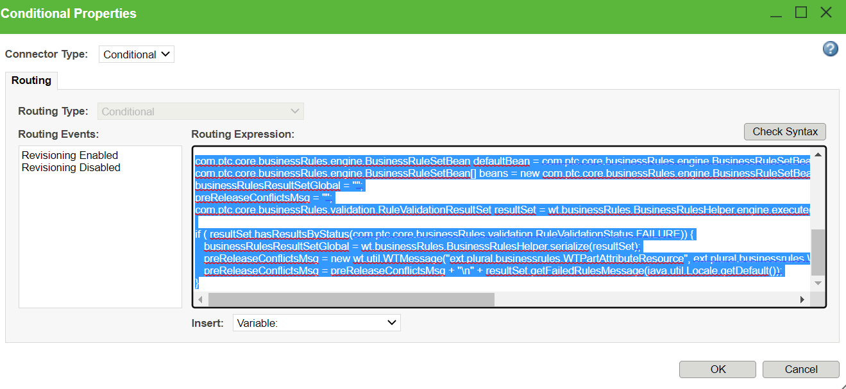
- Save the changes and check in workflow.

